ME and UNCLE ROMIE
Clair Hartfield

It was the summer Mama had the twins that I first met my Uncle Romie. The doctor told Mama she had to stay off her feet till the babies were born. Daddy thought it was a good time for me to visit Uncle Romie and his wife, Aunt Nanette, up north in New York City. But I wasn’t so sure. Mama had told me that Uncle Romie was some kind of artist, and he didn’t have any kids. I’d seen his picture too. He looked scary --- a bald-headed, fierce-eyed giant. No, I wasn’t so sure about this visit at all.

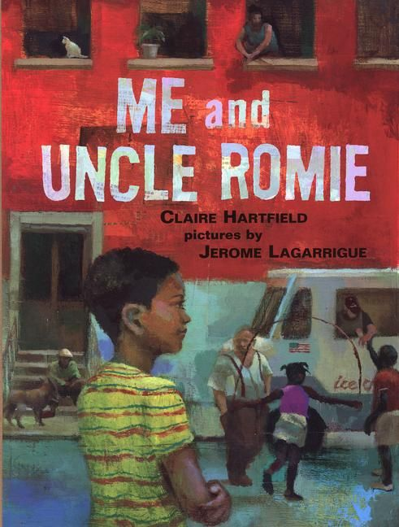
1
“Penn Station! Watch your step,” the conductor said, helping me down to the platform. I did like Daddy said and found a spot for myself close to the train. Swarms of people rushed by. Soon I heard a silvery voice call my name. This had to be Aunt Nanette. I turned and saw her big smile reaching out to welcome me.
She took my hand and guided me through the rushing crowds onto an underground train called the subway. “This will take us right home,” she explained.
Home was like nothing I’d ever seen before. No regular houses anywhere. Just big buildings and stores of all kinds - in the windows I saw paints, fabrics, radios, and TVs.
We turned into the corner building and climbed the stairs to the apartment – five whole flights up. WHEW! I tried to catch my breath while Aunt Nanette flicked on the lights.
“Uncle Romie’s out talking to some people about his big art show that’s coming up. He’ll be home soon,” Aunt Nanette said.
2
She set some milk and a plate of cookies on the table for me. “Your uncle’s working very hard, so we won’t see much of him for a while. His workroom – we call it his studio - is in the front of our apartment. That’s where he keeps all the things he needs to make his art.”
“Doesn’t he just paint?” I asked.
“Uncle Romie is a collage artist,” Aunt Nanette explained. “He uses paints, yes. But also photographs, newspapers, cloth. He cuts and pastes them onto a board to make his paintings.”
“That sounds kinda easy,” I said.
Aunt Nanette just laughed.
“Well, there’s a little more to it than that, James. When you see the paintings, you’ll understand. Come, let’s get you to bed.”
Lying in the dark, I heard heavy footsteps in the hall. A giant stared at me from the doorway. “Hello there James.” Uncle Romie’s voice was deep and loud, like thunder.

3
“Thanks for the pepper jelly,” he boomed.
“You have a good sleep, now.” Then he disappeared down the hall.
The next morning the door to Uncle Romie’s studio was closed. But Aunt Nanette had plans for both of us. “Today we’re going to a neighborhood called Harlem,” she said. “It’s where Uncle Romie lived as a little boy.”
Harlem was full of people walking, working, shopping, eating. Some were watching the goings-on from their fire escapes. Others were sitting out on their front stoops greeting folks who passed by – just like the people back home calling out hellos from their front porches. Most everybody seemed to know Aunt Nanette. A lot of them asked after Uncle Romie, too.
We bought peaches at the market, then stopped to visit awhile. I watched some kids playing stickball. “Go on, get in the game,” Aunt Nanette said, gently pushing me over to join them. When I was all hot and sweaty, we cooled off with double chocolate scoops from the ice cream man. Later we shared some barbecue on a rooftop way up high. I felt like I was on top of the world.
4
As the days went by, Aunt Nanette took me all over the city – we rode a ferry boat to the Statue of Liberty ---zoomed 102 floors up at the Empire State Building ---window-shopped the fancy stores on Fifth Avenue---and gobbled hot dogs in Central Park.
But it was Harlem that I liked the best. I played stickball with the kids again … and on a really hot day a whole bunch of us ran through the city’s cold water that sprayed out hard from the fire hydrant. In the evenings Aunt Nanette and I sat outside listening to the street musicians playing their saxophone songs.
On rainy days I wrote postcards and helped out around the apartment. I told Aunt Nanette about the things I liked to do back home - about baseball games, train-watching, my birthday. She told me about the special Caribbean lemon and mango cake she was going to make.
My Uncle Romie stayed hidden away in his studio. But I wasn’t worried anymore. Aunt Nanette would make my birthday special.
4 …. 3 …. 2 …. 1 …. My birthday was almost here!
5
And then Aunt Nanette got a phone call.
“An old aunt has died, James. I have to go away for her funeral. But don’t you worry. Uncle Romie will spend your birthday with you. It’ll be just fine.”
That night Aunt Nanette kissed me good-bye. I knew it would not be fine at all. Uncle Romie didn’t know about cakes or baseball games or anything except his dumb old paintings. My birthday was ruined!
When the sky turned black, I tucked myself into bed. I missed Mama and Daddy so much. I listened to the birds on the rooftop – their songs continued into the night.
The next morning everything was quiet. I crept out of bed and into the hall. For the first time the door to Uncle Romie’s studio was wide open. What a glorious mess! There were paints and scraps all over the floor, and around the edges were huge paintings with all sorts of pieces pasted together.
I saw saxophones, birds, fire escapes, and brown faces. It’s Harlem, I thought. The people, the music, the rooftops, and the stoops. Looking at Uncle Romie’s paintings, I could feel Harlem – its beat and bounce.
Then there was one that was different. Smaller houses, flowers, and trains. “That’s home!” I shouted.
“Yep,” Uncle Romie said, smiling. “That’s the Carolina I remember.”
“Mama says you visited your grandparents there almost every summer when you were a kid,” I said.
“I sure did, James. MMMM. Now that’s the place for pepper jelly. Smeared thick on biscuits. And when Grandma wasn’t looking … I’d sneak some on a spoon.”
“Daddy and I do that too!” I told him.
We laughed together, then we walked to the kitchen for a breakfast feast – eggs, bacon, grits, and biscuits.
“James, you’ve got me remembering the pepper jelly lady. People used to line up down the block to buy her preserves.”
“Could you put someone like that in one of your paintings?” I asked.
“I guess I could.” Uncle Romie nodded. “Yes, that’s a memory just right for sharing. What a good idea, James. Now let’s get this birthday going!”
He brought out two presents from home. I tore into the packages while he got down the pepper jelly and two huge spoons. Mama and Daddy had picked out just what I wanted - a special case for my baseball cards, and a model train for me to build.
“Pretty cool,” said Uncle Romie. “I used to watch the trains down in North Carolina, you know.”
How funny to picture big Uncle Romie lying on his belly watching the trains.”
My friend B.J. and me, we have contests to see who can hear the trains first.”
“Hey, I did that too. You know, it’s a funny thing, James. People live in all sorts of different places and families. But the things we care about are pretty much the same. Like favorite foods, special songs, games, stories … and like birthdays.” Uncle Romie held up two tickets to a baseball game!
It turns out Uncle Romie knows all about baseball – he was even a star pitcher in college. We got our mitts and set off for the game.

Way up in the bleachers, we shared a bag of peanuts, cracking the shells with our teeth and keeping our mitts ready just in case a home run ball came our way. That didn’t happen – but we sure had fun.
Aunt Nanette came home that night. She lit the candles and we all shared my Caribbean birthday cake.
After that, Uncle Romie had to work a lot again. But at the end of each day he let me sit with him in his studio and talk. Daddy was right. Uncle Romie is a good man.
The day of the big art show finally came. I watched the people laughing and talking, walking slowly around the room from painting to painting. I walked around myself, listening to their conversations.
“Remember our first train ride from Chicago to New York?” one lady asked her husband.
“That guitar-playing man reminds me of my uncle Joe,” said another.
All these strangers talking to each other about their families and friends and special times, and all because of how my Uncle Romie’s paintings reminded them of these things.
Later that night Daddy called. I had a brand new brother and sister. Daddy said they were both bald and made a lot of noise. But he sounded happy and said how they missed me.
This time Aunt Nanette and Uncle Romie took me to the train station.
“Here’s a late birthday present for you, James.” Uncle Romie said, holding out a package. “Open it on the train, why don’t you. It’ll help pass the time on the long ride home.”
I waved out the window to Uncle Romie and Aunt Nanette until I couldn’t see them anymore. Then I ripped off the wrappings!
And there was my summer in New York. Bright sky in one corner, city lights at night in another. Tall buildings. Baseball ticket stubs. The label from the pepper jelly jar. And trains. One going toward the skyscrapers and another going away.
Back home, I lay in the soft North Carolina grass. It was the first of September, almost Uncle Romie’s birthday. I watched the birds streak across the sky.
Rooftop birds, I thought. Back home from their summer in New York, just like me! Watching them, I could still feel the city’s beat inside my head.
A feather drifted down from the sky. In the garden tiger lilies bent in the wind. They were Uncle Romie’s favorite flowers. I yanked off a few blossoms. And then I was off on a treasure hunt, collecting things that reminded me of Uncle Romie.
I painted and pasted them together on a big piece of cardboard. Right in the middle I put the train schedule. And at the top I wrote:
HAPPY BIRTHDAY
UNCLE ROMIE

