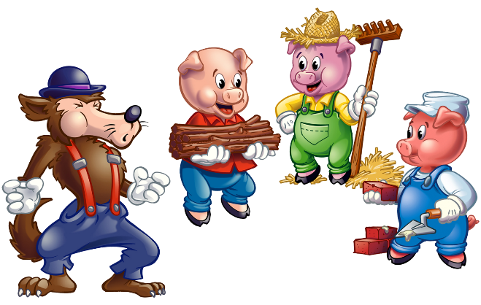
The Three Little Pigs
There was an old mother pig that had three little pigs. She did not have enough to feed them so she sent them out into the world to seek their fortunes.
The first little pig went off and met a man with a bundle of straw. He said, “Please, man, give me some straw to build my house.”
The man gave him the straw and the little pig built a house. But soon a wolf came along and knocked at the little door. The wolf said, “Little pig, little pig, let me come in.”
“No, no,” said the little pig, “not by the hairs of my chinny chin chin. I will not let you come in.”
“Then I’ll huff, and I’ll puff and I’ll blow your house in.”
So he huffed and he puffed and he blew the little straw house in and then he ate the first little pig.

The second little pig met a man with a bundle of sticks and said, “Please, man, will you give me those sticks to build my house.”
The man gave him the sticks and the little pig built a house. But soon the wolf came along and knocked at the little door. The wolf said, “Little pig, little pig, let me come in.”
“No, no,” said the little pig, “not by the hairs of my chinny chin chin. I will not let you come in.”
“Then I’ll huff, and I’ll puff and I’ll blow your house in.”
So he huffed and he puffed and he huffed and he puffed and he blew the little stick house in and then he ate the second little pig.

The third little pig met a man with a load of bricks.
He said, “Please, man, give me some bricks so I can build a house.”

So the man gave him some bricks and he built a house with them. The wolf came along and knocked at the little door. The wolf said, “Little pig, little pig, let me come in.”
“No, no,” said the little pig, “not by the hairs of my chinny chin chin. I will not let you come in.”
“Then I’ll huff, and I’ll puff and I’ll blow your house in.”
So he huffed and he puffed and he huffed and he puffed some more, but he could not blow down the little house.
“Little pig, I know where there is a nice field of turnips.”
“Where?” asked the little pig.
“Oh, at Mr. Smith’s farm. If you will be ready tomorrow morning I will came by and we can go together. We can get some turnips for dinner.”
“Very well,” said the little pig, “I will be ready. What time do you want to go?”
“Oh, we should leave at six o’clock.”
Well, that little pig got up at five, and got the turnips before the wolf came by.
“Little pig,” he called, “are you ready to go?”
“Ready! I have already gone to the farm and come back again. I got a nice potful of turnips for dinner.”
The wolf was very angry, but thought that he would try again.
“Little pig, I know where there is a nice apple tree.”
“Where?” asked the pig.
“Down by the garden. And if you don’t trick me again I will come by for you at five o’clock tomorrow. We can get some apples together.
Well, that little pig got up at four o’clock and went off to get the apples. But as he was going home, he saw the angry wolf coming and the pig became afraid.
“Little pig! Why are you here before me? Are they nice apples?”
“Oh, yes. I will throw one down for you.”

And he threw that apple so hard and it went so far that the wolf had to run after it. While the wolf was running after the apple the little pig jumped down from the tree and ran all the way home.
The next day the wolf came by again.
“Little pig, there is a fair today. Do you want to go?”
“Oh, yes,” said the pig. “What time should I be ready?”
“Be ready at three,” said the wolf.
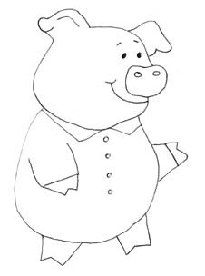
So the pig left for the fair before three. He bought a butter churn and was heading home when he saw the wolf. The little pig did not know what to do so he jumped into the butter churn to hide. The butter churn tipped over and began to roll down the hill. It rolled right toward the wolf.
The wolf was so afraid that he ran to the pig’s house and told the pig that a great round thing had come down the hill after him.
“Hah! That was me! I scared you!” cried the pig.
The wolf was very very angry. He said he would eat the little pig by going down the chimney. When the little pig heard what the wolf was going to do he put a big pot of water over the fire in the fireplace. The wolf fell into the pot. The little pig boiled him up and ate him up for supper.
And the little pig lived happily ever after!

